Sleeves and spacers
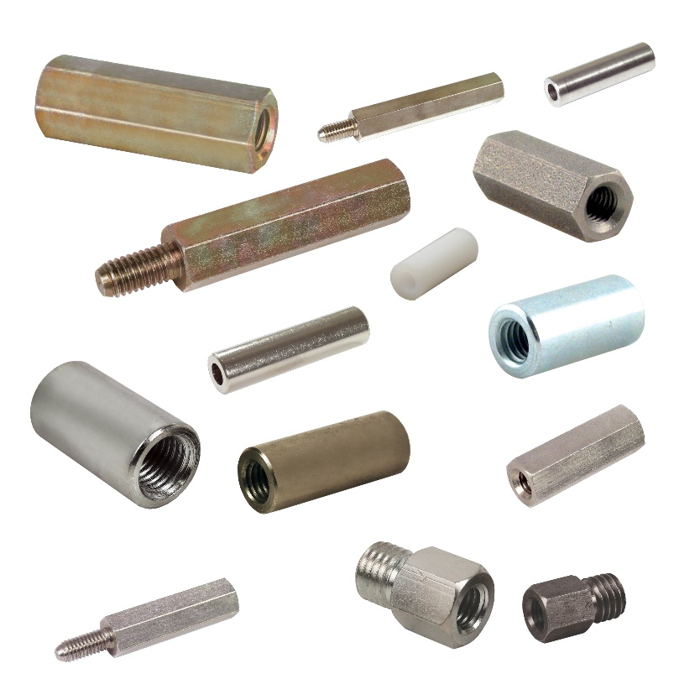

Engrenages HPC offers a complete range of spacers and sleeves in its catalogue. These threaded components are most often used in electronic assemblies to raise printed circuit boards above a surface. Their main function is to separate 2 elements and guarantee that they do not come into contact. Cylindrical or hexagonal in shape and with male/female or female/female ends, they are available in steel, brass, stainless steel or plastic.

Through-threaded sleeves are an ideal solution for joining two threaded rods. In addition, female/female reducing sleeves allow two rods of different diameters to be connected. Reducer sleeves are also available in male/female versions.

Many different dimensions are included in the catalogue and most are available for delivery from stock

